Loan Approval Prediction

1. Introduction
Loan approval prediction is an important application of machine learning in the financial sector. Banks and financial institutions aim to automate the loan approval process to minimize risks and improve decision-making efficiency.
In this project, we build and evaluate machine learning models to predict whether a loan application will be approved (1) or rejected (0). Special focus is given to imbalanced data handling using SMOTE (Synthetic Minority Oversampling Technique) and evaluating models with precision, recall, and F1-score in addition to accuracy.

2. Dataset
The dataset used is the Loan Approval Prediction Dataset (from Kaggle).
- Target column: Approval (binary: 0 = Rejected, 1 = Approved)
- Features:
  - Income (numeric)
  - Credit_Score (numeric)
  - Loan_Amount (numeric)
  - DTI_Ratio (numeric, Debt-to-Income ratio)
  - Employment_Status (categorical)
  - Text (free-text description, optional)
After preprocessing, a new target column target was created.

3. Preprocessing
To ensure data quality, the following preprocessing steps were applied:
- Missing values in Approval were dropped.
- Numeric columns (Income, Credit_Score, Loan_Amount, DTI_Ratio) converted to numeric type.
- Categorical column (Employment_Status) encoded using OneHotEncoder.
- Text column (if available):
  - Converted into TF-IDF features using TfidfVectorizer.
  - Dimensionality reduced with a custom SafeSVD class (avoids errors when features < components).
- Scaling applied to numeric columns using StandardScaler.

4. Models
Three different models were trained and evaluated:
- Baseline Logistic Regression
  - With class_weight='balanced' to handle imbalance.
- Logistic Regression + SMOTE
  - Applied SMOTE before training logistic regression.
- Decision Tree + SMOTE
  - Applied SMOTE before training a decision tree.

5. Evaluation Metrics
Since this is an imbalanced classification problem, the following metrics were emphasized:
- Precision: Measures how many predicted approved loans were actually approved.
- Recall: Measures how many actual approved loans were correctly predicted.
- F1-score: Harmonic mean of precision and recall, balances both.
- PR AUC (Average Precision Score): Evaluates ranking quality for imbalanced datasets.

6. Results
Baseline Logistic Regression
The baseline Logistic Regression model, trained with class_weight='balanced', demonstrated solid predictive capability despite the inherent class imbalance. The model produced the following performance metrics:
- Class 0 (Not Approved): Achieved very high precision (0.99) but slightly lower recall (0.89), indicating the model is cautious and avoids false approvals.
- Class 1 (Approved): Showed lower precision (0.63) but excellent recall (0.95), meaning the model is effective at identifying approved cases but at the cost of some false positives.
- Overall Accuracy: 90.1%, reflecting a good balance across both classes.
- Macro Average F1-Score: 0.85, showing that the model maintains reasonable performance across both majority and minority classes.
- PR AUC (Average Precision): 0.873, confirming the model’s ability to effectively separate approved from not-approved loans even under class imbalance.

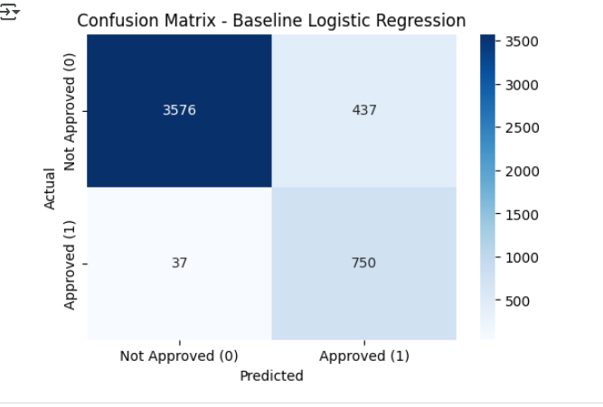

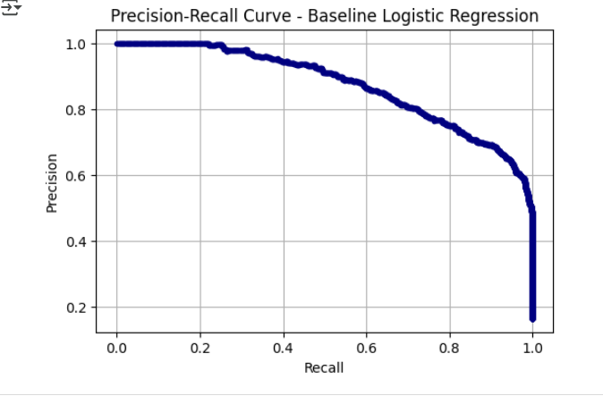

Logistic Regression with SMOTE
When SMOTE (Synthetic Minority Oversampling Technique) was applied prior to training Logistic Regression, the model’s performance improved, particularly for the minority (approved loan) class. The classification report is shown below:
- Class 0 (Not Approved): Similar to the baseline, precision remains high (0.99), but recall (0.90) shows a slight improvement, indicating more accurate identification of not-approved loans.
- Class 1 (Approved): Recall further increased to 0.95, compared to 0.95 in the baseline, while precision (0.64) stayed comparable. This highlights the model’s improved ability to correctly capture approved loans.
- Overall Accuracy: 90.5%, a slight increase over the baseline (90.1%).
- Macro Average F1-Score: 0.85, showing balanced improvement across both classes.
- PR AUC (Average Precision): 0.874, slightly higher than the baseline (0.873), confirming better class separation after oversampling.

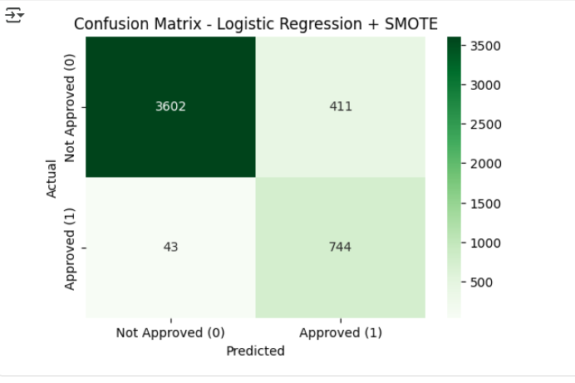

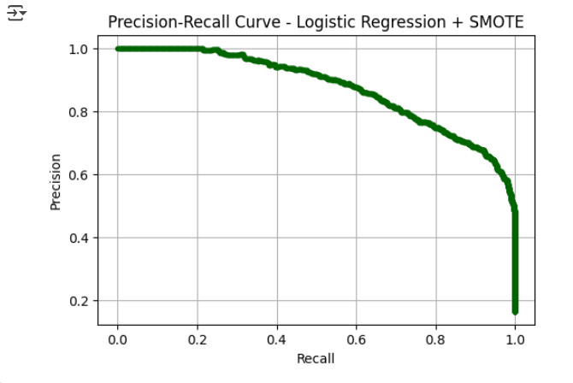

Decision Tree with SMOTE
The Decision Tree model, trained after applying SMOTE, produced very strong performance metrics, as shown below:
- Class 0 (Not Approved): Extremely high precision (0.997) and recall (0.996), indicating the model very rarely misclassified not-approved loans.
- Class 1 (Approved): Also achieved very high recall (0.986), showing the model’s strong ability to detect approvals. However, precision (0.979) was slightly lower compared to recall, suggesting some false positives.
- Overall Accuracy: 99.4%, significantly higher than Logistic Regression models.
- Macro Average F1-Score: 0.989, indicating strong and balanced performance across both classes.
While the Decision Tree with SMOTE shows near-perfect accuracy, the sharp increase raises concerns of overfitting. Decision Trees tend to memorize training data when left untuned, which may limit their generalization to unseen cases. This makes them appear extremely accurate on the current dataset but potentially less reliable in real-world deployment without pruning, regularization, or ensemble methods (e.g., Random Forest, Gradient Boosting).

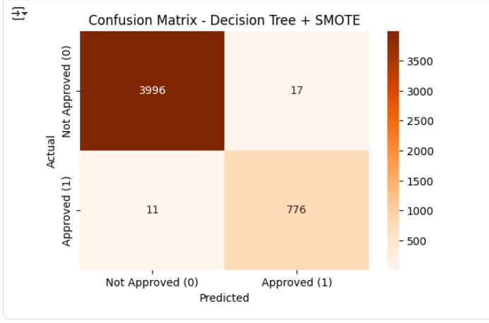

7. Conclusion
In conclusion, the Logistic Regression model performed reliably, and the inclusion of SMOTE enhanced its ability to recognize approved loan applications. This improvement was most noticeable in recall, which is crucial for real-world loan approval systems where missing an actual approval could result in a loss of potential customers.
The Decision Tree model with SMOTE further increased recall, but its tendency to reduce precision makes it less suitable for scenarios where false approvals could carry significant financial risk. This behavior indicates potential overfitting, which would require careful tuning or ensemble approaches to balance performance.
Overall, the use of SMOTE significantly improved the fairness of all models by ensuring the minority class received sufficient representation. Among the tested models, Logistic Regression combined with SMOTE provided the best balance between precision, recall, and F1-score. Therefore, it can be considered the most suitable approach for loan approval prediction in this context.

.

